Daughter of sick elderly mother believes the NHS need to create a larger awareness of the care options available for the elderly at times which are distressing for families.
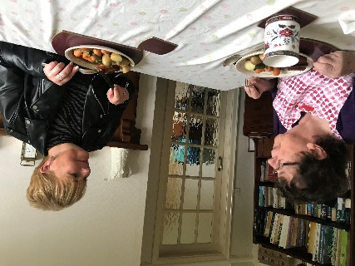
Linda Howes, daughter of Parkinson’s and Dementia sufferer Jane Brook, had to fight for her mother’s needs to be viewed as nursing needs to enable her to receive care from her own home in Nottingham, rather than a care home.
She believes “the process should be made clearer and the access to funding shouldn’t be the fight that it often seems to be.”
The care system for the elderly determines what care they receive depending on what category they fall into due to their needs; nursing needs or social needs.
Social care costs are capped, means tested and rationed: the difference is that nursing care costs are fully funded and have never been capped.
At the moment, around sixty thousand people qualify for nursing care but are being veered towards social care options by professionals.
Linda believes this is due to the fact nursing care is “very expensive and the government have to meet the cost of that.”
From Linda’s own experience she discovered that in October 2017, the NHS were warned about forcing elderly people into care homes and that this was in fact breaching their human rights.
She revealed the quality in human rights commission said that this was “discrimatory, depriving people of family life, splitting families and giving them no choice of where they can be cared for.”
Some health commissioners say they will only contribute 10% the cost of a care home towards the funding for someone’s care at home, which is also veering people towards care homes due to the expense of the alternative.
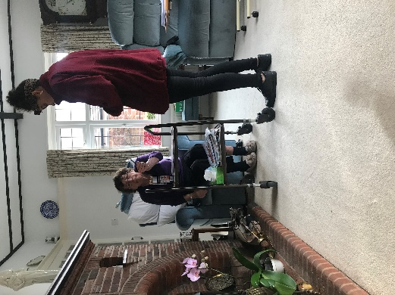
By applying this cap, they don’t consider the benefits of a person remaining in their home such as their family, social aspects, psychological aspects and the health benefits.
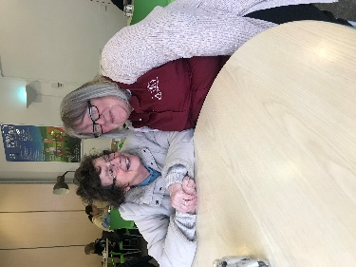
Jane’s carer, Anneli, believes the elderly have a better quality of life by being cared for at home and it enables them to stay in their own surroundings as it’s quite upsetting for them when they go into nursing homes.
The carer of 10 years says Jane is “more relaxed at home and recognises where things are and where she is so it’s all familiar and creates less confusion” for her.
Linda believes “the framework is very complex” and the process for determining whether somebody is actually able to access care at home is “very arduous and subjective,”.
Because of these reasons she believes the existing care system should be made clearer and easier at a time which is “very very distressing for families.”

